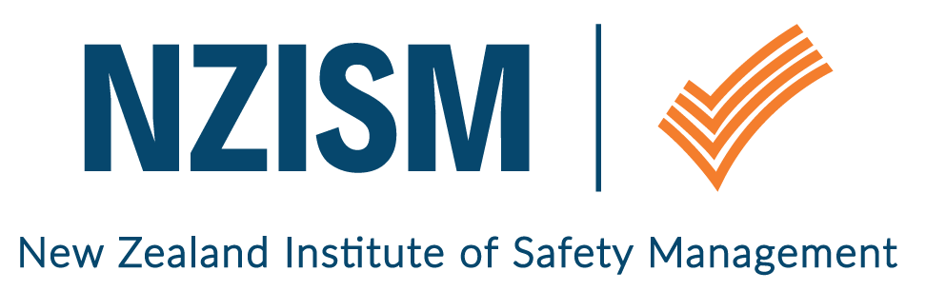
Wellington Branch

February 2019 Newsletter

Review of last event | Understand your Risk Management Landscape was the topic of the first monthly seminar for 2019. Michael Jones shared his wealth of knowledge with an audience of 40 people, made up of NZISM members and their guests. His statement that organisations must focus on what’s important, not what’s interesting when assessing risk, was supported by him showing us what the language of risk assessment means in simple terms and how to assess risk in a practical way.  One take out we should all remember, is that assessment of risk does not sit solely with Health and Safety - different people from across an organisation must be involved to ensure all perspective are considered.  Michael has generously shared his powerpoint presentation and the risk register template he uses. You can download these off the Wellington Branch page on the NZISM website.
March event  The National Library  70 Molesworth Street  Wellington | Tuesday 5 March  We’re still working on the next seminar, but mark the date in the diary and we look forward to seeing you there.  12:00pm – 12:15pm: Doors open, arrival and networking  12:15pm – 1.00pm: Speaker begins  1.00pm – 1.15pm: Networking  1.30pm: Doors close  If you know of a speaker or if you’d like to present on a topic yourself, please get in touch.
Bring a guest
Members are encouraged to bring along guests to the monthly seminars. Whilst there is a preference to translate the visits to membership, our focus is on growing risk management awareness amongst a cross section of people. Safety is everyone’s responsibility – not just the H&S professional.
Local H&S scene / What’s going on | NZISM were delighted to host a lunch and panel discussion for the Government Health and Safety Lead (GHSL) Summer interns on 29 January. Held at Corrections Head Office on The Terrace, Mike Cosman, Kim Payton, Margaret van Scheik and Bruce McKay represented NZISM, answering questions from the interns that included where we saw health and safety in NZ and globally in 10 years’ time, and what our proudest moment had been in our careers to date.  The panel were impressed by the quality of the discussion and enjoyed the opportunity to promote the value of professional membership of NZISM and HASANZ.  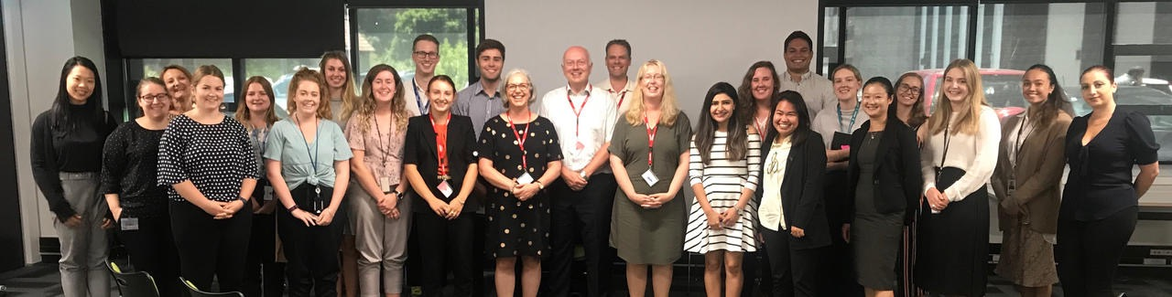  Here’s some specific feedback from the interns about the event:  - It was informative and insightful, and it was good to hear personal experiences of the profession from a range of people at varying levels.  - The way they kept our experience as interns, particularly when talking about NZISM and the benefits of joining a professional body, was great as it made it more applicable.  - The concept of health and safety wasn’t overcomplicated. When answering questions about challenges in the health and safety sector, and what you think it would look like in 10 years, emphasis was placed on people and practicality.  NZISM have offered the interns free membership for a year, so Wellington Branch is looking forward to seeing some at our monthly events and introducing them to the wider membership.  St John Mental Health First Aid Training – Member Offer  In case you missed it, make sure you’ve checked out the workshop St John is offering NZISM members. The Wellington workshop is on 4 April 2019.  NZISM Monthly Webinar – an introduction to the NZISM accreditation programme  This will be on Wednesday 13 February at 7.00pm.  And remember you can still access NZISM webinars you may have missed by logging on to the Members only page on the NZISM website.  If you’d like to promote an event or share information that would be of interest to NZISM members, please email well.nzism@gmail.com.
Vacancy | Deb Cameron, Branch Manager of BOP NZISM, is also the HSER Business Partner at C3 and she has asked us to share information about vacancy in the C3 southern region. Deb is keen to have a NZISM member join her team, so if you’re interested, click here for more information on the Wellington Branch page of the NZISM website.
Other Information | Contact information  A reminder to ensure your profile on the NZISM website – https://www.nzism.org is up to date. The success of the Wellington branch relies on the input of its members and our ability to send communications to you.
Important stuff to know | Wellington monthly events are scheduled for the first Tuesday of every month at The National Library, Thorndon. Keep an eye on the NZISM calendar on the website for more information.  A reminder also to check out our neighbouring Regions events on the NZISM Calendar. There may be something on in another Branch that is relevant to you.

